Evaluation of the
Open Education Consortium

Final Report – 31 March, 2016

Authors
Linda Shear, Emi Iwatani, Barbara Means, Rebecca Griffiths
SRI International

This report is licensed under a Creative Commons Attribution 4.0 International license.

Contents

Introduction 1
About this Evaluation 2
About the Open Education Consortium 6
Contributions and Challenges 15
OEC in Context: The OER Ecosystem 27
Charting a Future Role for OEC 33
References 38
Appendix A. Evolution of the Open Education Consortium 39

Introduction
The Open Education Consortium (OEC) comprises a network of nearly 300 education institutions globally. Its goal is to advance the use of open educational resources (OER), and promote open education around the world, primarily in higher education.
The William and Flora Hewlett Foundation (Hewlett Foundation), one of the most prominent leaders of the OER movement, has been providing financial support for a wide range of OEC activities since 2007. While OEC plays a number of very important roles in the OER community, the Foundation and OEC wanted to know which efforts have been most fruitful. In addition, after OEC’s major strategic expansion of its focus in 2014—from open courseware to open education more broadly— the time seemed right for OEC to reflect on its early post-transition efforts, to inform its future direction. As it considered the best avenues of future support for OEC, the Hewlett Foundation asked SRI International to study the value that OEC offers within the OER landscape, and to make recommendations for promising alternatives for future directions.
This evaluation project was designed to offer insights for both the Foundation and the Consortium. In close consultation with OEC leaders, and with insights from OEC members and active leaders in the OER community, SRI aimed to support the evolution of the organization’s value proposition, and to provide formative input for ongoing OEC activities.
In this report, after a summary of our evaluation questions and methodology, we describe OEC’s mission, major activities, and member involvement in those activities. We then summarize how key actors in the OER ecosystem—including OEC members and others who are very active with OER globally—perceive OEC’s role and value. The final sections of this report put OEC’s work in the context of the larger ecosystem that creates and sustains OER and related practices, present perceived challenges to that ecosystem, and outline suggested future directions for OEC.

About this Evaluation

Evaluation Questions

Our research questions center on OEC and its current and potential relationship with the greater OER landscape:
- What is the range of activities and functions that OEC facilitates? Who participates?
- What value do OEC participants perceive from these various activities? What value is perceived by others in the broader OER field?
- What concrete outcomes can be identified from the OEC’s work?
- What are the needs of the OER landscape today?
- What possible future directions appear likely to be fruitful? How might OEC focus its work ongoing?

Methods
This research drew data from multiple sources: (1) existing materials, (2) interviews with key players in the global OER field, and (3) a member survey.
We reviewed available materials such as OEC proposals and reports, strategic planning documents, website statistics, and artifacts available on the OEC website, and researched some of the main organizations involved in the higher education OER ecosystem. We met with Mary Lou Forward, the Executive Director of OEC, to discuss program goals, key activities, experiences, outcomes to date, and other elements of an OEC logic model. This meeting also helped refine our research questions and methodology.
Interviewees included OEC member institutions, board members, staff, and leaders of partner institutions (i.e., those that have conducted work with OEC), and some individuals who were not directly connected to OEC but were deeply familiar with the general OER landscape. An important consideration for selecting interviewees was global diversity. Since OEC is international in its mission, organization and reach—according to 2014 materials from OEC, their membership includes representatives from 50 nations across 6 continents, representing 29 languages—interviews were designed to harness perspectives from around the world. The 15 informants we interviewed represented 10 countries across 5 continents, and included individuals who were very well informed about continental and/or global OER activities. The interviews were conducted by telephone or video conferencing, and took 45 minutes to an hour each.
The survey was conducted online in late November 2015, and consisted of items inspired by our research questions. OEC is a consortium of institutions, and the survey went to the individuals within these institutions who are the primary representatives to OEC. Of the 272 unique OEC member representatives representing 274 institutions, 15 did not have valid email addresses, and two could not access the survey due to firewall restrictions, resulting in 255 possible respondents. Of those, 63 representatives fully completed the survey, and an additional 18 partially completed the survey, resulting in a response rate between 32% and 25% per item. While the results reported here represent probable trends, in light of the low response rate, we cannot be confident that they represent the OEC membership overall.

Background of Survey Respondents
The OEC member representatives who responded to at least some part of the survey were from North America (36%), Asia (26%), Europe (21%), Latin America and the Caribbean (14%), Africa (3%), and Oceania (1%). Approximately a third of the survey respondents were from institutions based in emerging or developing economies. Thus, relative to the overall membership, there was an overrepresentation of members from the Americas, an underrepresentation of members from Asia, and an overrepresentation of those from emerging or developing economies (Table 1). The survey respondents reported that they had been OEC members for between less than a year to 15 years, with an average of 4.9 years, which is similar to the general OEC membership.

Table 1. Geographic region and economy type of survey responders and OEC membership.
 | Percentage of survey responders (N=81) | Percentage of OEC membership (N=286)
Africa | 2 | 2
Asia | 26 | 41
Europe | 21 | 21
Latin America and the Caribbean | 14 | 10
North America | 36 | 26
Oceania | 1 | 1
Advanced economies | 36 | 26
Emerging or developing economies | 64 | 76

As shown in Figure 1, the majority of institutions represented by survey respondents were accredited postsecondary education institutions (71%), while others identified as other organizations or institutions (16%), associations of greater than five institutions (11%), or corporations (1%). This distribution is very similar to that of the general membership. Among institutes of higher education represented by respondents, a majority (60%) conferred primarily 4-year degrees, while others conferred primarily 2-year degrees (17%), postgraduate degrees (16%), certificates (5%), or a mix of these degrees (2%). Approximately two-thirds of the institutions represented by survey responses had 25% or fewer distance education students, whereas a fifth of these institutions had 76-100% of their students learning at a distance.

Figure 1. OEC survey respondent membership type (N=81).

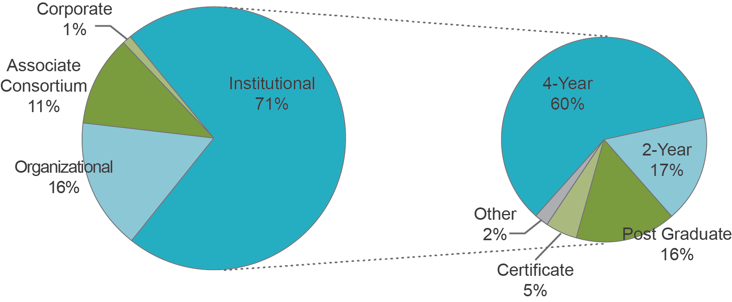
The individuals who responded to the survey consisted of higher education leadership/management (39%), full-time professors or instructors (16%), educational project managers (13%), instructional designers (8%), librarians (4%), and others (16%). Three-quarters (76%) of respondents had OER or OE as part of their professional duties.

About the Open Education Consortium
We turn now to a basic introduction to the Open Education Consortium: its mission and main activities, patterns of member involvement, and members’ stance toward OER and reasons for joining OEC.

OEC Mission and Activities
OEC describes itself as “a global network of educational institutions, individuals and organizations that support an approach to education based on openness, including collaboration, innovation and collective development and use of open educational materials” (OEC 2015a). Its mission is to “promote, support and advance openness in education around the world,” and its members envision a world in which “everyone, everywhere has access to the high quality education and training they desire; where education is seen as an essential, shared, and collaborative social good” (ibid.).
OEC originally began as the OpenCourseWare Consortium (OCWC), a consortium of institutes of higher education interested in making their course materials freely and openly available to the world, as a service to society. The Hewlett Foundation, Massachusetts Institute of Technology (MIT), and Carnegie Mellon University (CMU) were early leaders of this movement: with the support of the Hewlett Foundation, MIT launched MIT OpenCourseWare, and CMU launched their Open Learning Initiative, in the fall of 2002. With many institutes of higher education following that lead, the OCWC was established in 2005, as an association for institutes of higher education to support one another in advancing the impact and sustainability of the OpenCourseWare movement. While OCWC was initially hosted by MIT, it became an independent not-for-profit organization in 2009. The organization’s key activities since then are summarized in Appendix A.
In early 2014, OCWC broadened its mission from supporting open course materials specifically to supporting open education, and the use of open educational resources and practices, more generally. It changed its name to the Open Education Consortium (OEC), reflecting this broadening of mission and scope. This strategic shift in focus was motivated by a number of factors, particularly by considerations about how to remain most helpful to the OER community as the concerns of that community continued to broaden beyond courseware. Leaders specifically made the decision not to become the “OER Consortium,” as they recognized that the core belief uniting the members was about improving access to high quality education, a more encompassing goal than solely promoting more use of OER.
As summarized on its website, OEC’s activities consist of awareness raising, networking and community development, advocacy and advising, capacity building and training, and implementation support and consultancies. In recent years, specific core activities have included hosting an annual international conference on open education (OE Global), leading the organization of a global awareness week on open education (Open Education Week), and conducting specific consultancies and projects related to open education and OER. These consultancies and projects have ranged in their scope and purpose, from helping a university in Latin America improve access to education using OER, and curating OER content for non-profit organizations, to co-sponsoring high-level policy summits with the United Nations Educational, Scientific and Cultural Organization (UNESCO) and the International Council for Open and Distance Education (ICDE) to inform recommendations for the United Nations’ Sustainable Development Goals. In some instances, OEC has helped connect member institutions to projects, while in other cases OEC staff members have worked on these projects directly. Aside from OE Global and Open Education Week, OEC also makes available several regular opportunities for members to share and showcase their work, including bimonthly newsletters, quarterly online membership meetings, listservs, and an online directory for experienced open education professionals. OEC also recognizes notable accomplishments of open education professionals through their Open Education Awards for Excellence, and offers an OER search engine, in collaboration with MERLOT.

Reasons for Supporting OER and Joining OEC
As of the fourth quarter of 2015, OEC consisted of 268 member institutions and organizations, from 6 continents and 50 countries. As shown in Figure 2, over half of the members are based either in the US or East Asia (especially Taiwan, South Korea and Japan), and 21% are based in Europe. Three quarters (76%) of the members are institutes of higher education that “demonstrate significant support for the production, use and/or promotion of OER, or support openness of education” (OEC 2015b). Membership also includes other types of organizations (18%), consortia (5%), and corporations (1%). Membership fees for institutions and organizations ranged between 225 to 750 USD per annum in 2014/15, depending on the institution’s economy status and membership type. Survey responses suggest that member representatives are generally very enthusiastic about using, producing and/or sharing OER (Figure 3) while the larger institutions they represent are typically somewhat milder supporters, supporting observations by some interviewees that OER is still a movement consisting largely of individual enthusiasts who are passionate about the cause.
Figure 2. OEC membership by country in late 2015 (N=268)
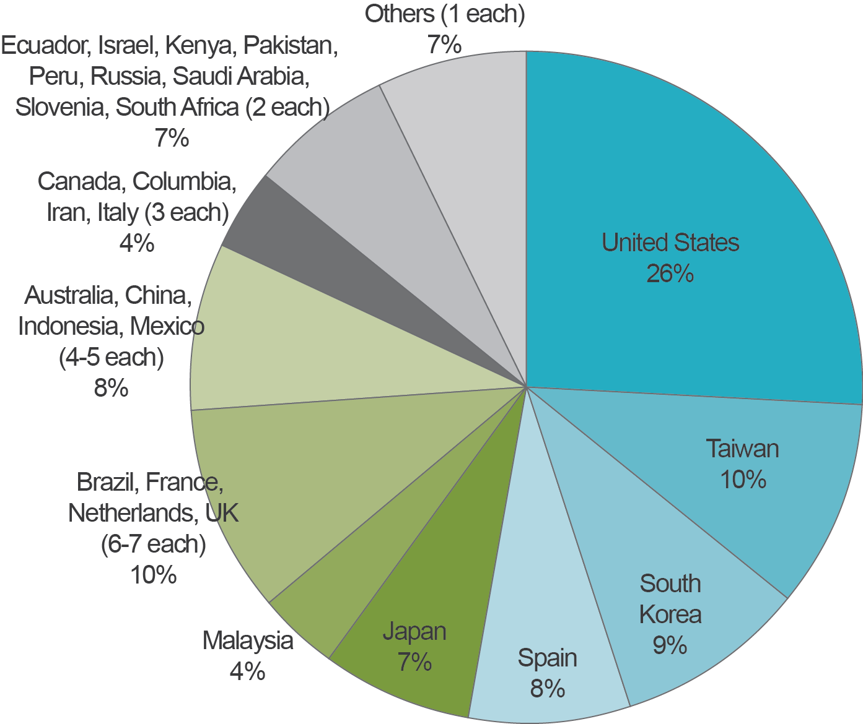

Figure 3. OEC survey respondent institution and member representative enthusiasm for OER (N=80).
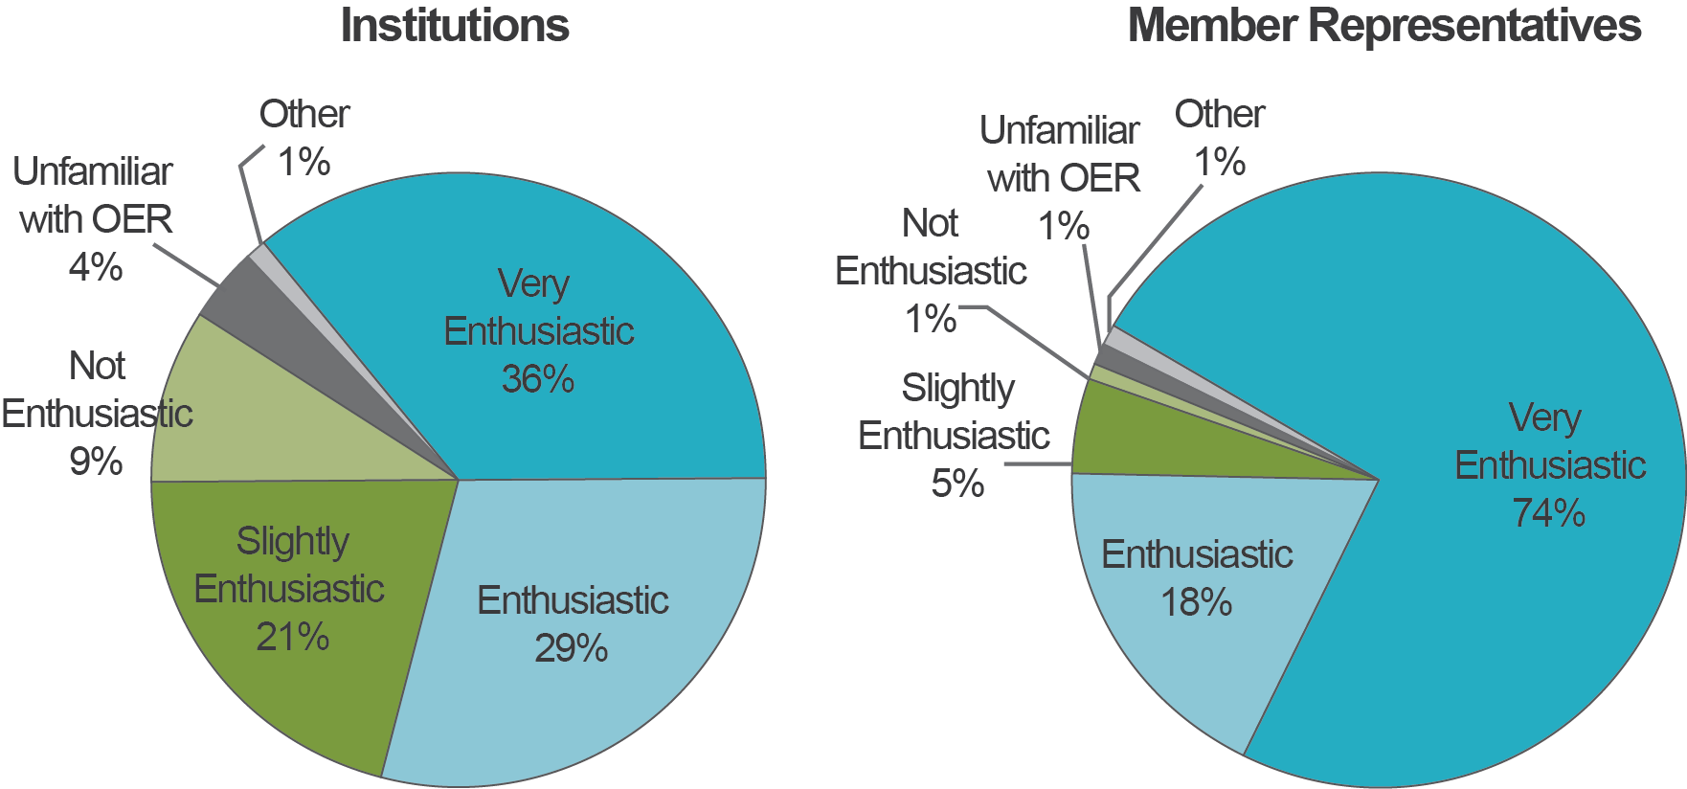

The member institutions support OER for a variety of reasons. According to the member survey, the greatest reasons for their institutions’ support of OER (Figure 4) were ideological, including the belief in the idea of quality education for all, and the belief in the philosophy of sharing education, with over 70% of respondents viewing these as a “major reason” for their institution to support OER. Other major reasons included easy, convenient and/or free access to high quality educational resources (over 60%), or improvement of services, improvement in institutional image, and ease of adaptability of OER (over 40% each).
Because OEC’s mission is deliberately global in scope, some analyses in this report look at possible differences in perspectives or experiences between respondents that represent advanced economies and those from emerging or developing economies. On the topic of drivers of support for OER there were some notable differences between these two groups (Table 2). Respondents from emerging or developing economies were much more likely to respond that free and/or easy access and modifiability of high quality educational resources were major reasons for their support of OER. These respondents were also slightly more likely to say that supporting OER improves the services and/or image of their organization. The ideological reasons where shared equally across these types of economies.
Figure 4. Reasons member institutions support OER (N=75 to 77).

Table 2. Major reasons for supporting OER by economy type (N=75 to 77).
 | Advanced Economy percentage  (N=46 to 49) | Emerging/Developing Economy percentage (N=26 to 27)
Belief in “quality education for all” | 76 | 77
Belief in the philosophy of sharing | 71 | 73
Easy/convenient access to high quality resources | 59 | 74
Free access to high quality resources | 59 | 74
Improves organization’s quality of services | 41 | 46
Improves organization’s reputation | 40 | 48
Ease of adaptation of resources | 31 | 50

Members shared a variety of reasons for becoming an OEC member through their responses to an open-ended question (Table 3). The most commonly-cited reasons were mission alignment and desire to support the cause (54%), and desire to belong to, share, and exchange information within a professional community (43%). One respondent explained, for example, that their institution is a member of OEC because they “support the idea of open education and actively promote this [nationally],” and furthermore, because “[international] cooperation is a great enrichment, maybe even crucial, to these activities.” Another institution joined OEC to “exchange experience and knowledge about OER with other members, as well as to diffuse its related activities worldwide.”
Respondents were seemingly less motivated by more pragmatic goals such as receiving news, resources, and perspectives (selected by 15%), being supported on personal initiatives (8%), and other strategic purposes that serve the institution (6%). Some institutions saw OEC membership as important for increasing their visibility (15%).
Table 3. Reasons for joining OEC (N=72).
Reasons for OEC membership | Percentage
Belief in open education, mission alignment, support for the cause | 54
Belong to and/or share with the professional community | 43
Receive news, resources and/or new perspectives | 15
Increase visibility of the institution | 15
Longtime supporter of OEC/OCWC | 11
To receive support on specific initiatives | 8
Other strategic reasons for institution/organization | 6
Requested by government | 1
Not sure | 1
Unclear response | 8

OEC Member Involvement
OEC members have participated in specific OEC activities to varying degrees (Figure 5). Among the membership survey respondents, the activity categories in which members were most involved over the past 2 years were participation in Open Education Week (54% across economy types), networking with other OEC members (53%), and attending the OE Global conference (46%) and OEC membership meetings (42%). Given the low response rate to this survey, it could be that those who invested time in the survey tended to be those who were more involved with OEC in these concrete ways. About 30-40% of respondents utilized OEC resources, including staff consultation, the Open Education Professional Directory and other material on their website. Relatively few respondents (between 16% and 19%) had contributed to the OEC community through serving on a committee, presenting on behalf of OEC, or contributing to a listserv, although a fair number (35%) featured their OEC affiliation in their institutional presentations or promotional materials.
Figure 5 also shows that with the exception of the use of OEC resources, respondents who were from advanced economies were much more likely to have participated in OEC activities.

Figure 5. Member involvement in OEC activities by economy type (N=74).
*
Percentage of respondents within economy type
*Parentheses indicate the percentage of total number of respondents selecting the response.
Once again, survey respondents are not a representative sample of OEC members. Assuming that Figure 5 represents meaningful trends, it is not surprising that attendance at face-to-face conferences, a very costly activity and particularly so for representatives of economies with weaker currencies, would be proportionally less common than use of OEC web resources, which are freely available to all. One hypothesis is that other network-related activities, such as networking with other members or using the OE professional directory, may be motivated more strongly for members who had the opportunity to meet face-to-face.
One OEC member who runs a consortium of OER researchers from around the Global South says that her organization has made significant investments to allow large groups of those researchers to attend the OE Global conference. She finds this “extremely important as a way of connecting [researchers across the Global South and North]. We've found that if you've made a face-to-face contact, then carrying on a virtual contact is pretty good. However, it's very hard to get into deep research conversations when you've only met online. So we really value these conferences, [even though] it's so expensive to get there.”

Contributions and Challenges
The previous section described an overview of the Open Education Consortium, its core activities, and the makeup and motivation of its members. We turn now to a discussion of how OEC is viewed by members and others in the OER ecosystem, focusing on the perceived role and value of the organization and on some of the challenges it faces.

Perception of OEC’s Role
Every interviewee who was familiar with OEC described it as a global organization with convening power, providing opportunities for OER and open education practitioners and/or researchers to network and learn from one another. Several also explicitly mentioned OEC’s advocacy role—to raise awareness and promote open education and the use of open educational resources around the world. One board member thought that to the general public, OEC might be best described as “a global advocacy organization that aims to use the concept of open education to promote access to education around the world,” while for those in the higher education community the description would be more specific, e.g., “an organization that promotes use of open education as a way to expand access to education, support the creativity of faculty members, and increase [student completion rates].” While some interviewees were familiar with the hands-on consulting and technical assistance that OEC has recently been providing to individual organizations/institutions, these were not typically mentioned in their broader description of OEC.
As with interviewees, survey respondents predominantly see OEC’s role as a convener that enables higher education institutions to network (Figure 6). All respondents reported that they would either “definitely highlight” or “might highlight” this role, when describing OEC to a colleague. Nearly all respondents would also highlight the role of OEC in helping higher education institutions and educators become more knowledgeable about OER. Consistent with reports from interviewees, respondents were less likely to highlight roles that sound closer to hands-on support (e.g., consulting with organizations about their open education programs; being a resource for how to create OER; helping the general public find high quality OER), or policy advocacy.
Based on the interviews we conducted, those close to OEC and its operations are of two minds about the consulting role that has recently been a growing focus of staff time and attention. The main organizational goal for taking on these activities has been financial diversification and stability, and at least one board member sees the approach as essential in order to keep OEC solvent. Others are concerned about the possibility of these activities diverting from OEC’s core mission: said one interviewee: “Those are tremendously time-consuming projects if you’re doing them well. You’re working for your money, and you’re working for your client, rather than working for your cause.” We will return to this issue in the recommendations section later in this report.
Figure 6. Roles OEC members would highlight when describing OEC to colleagues (N=64 to 65).

Perceived Value of OEC
Being a global convener, and providing committed open education and OER researchers and practitioners with opportunities for networking, were consistently described by interviewees as the most valuable contribution of OEC to the OER and broader open education community. Particularly through their annual conferences, but also through Open Education Week, newsletters, and other activities, OEC is described as providing a sense of community among international stakeholders, allowing for people to learn about each other’s work and know who to speak to if they want to learn about something, on topics such as OER policies in other regions of the world. When asked what would be lost without OEC, one interviewee responded:
I think it’s that global connection, because even though Creative Commons affiliates and OERu [also do convening work pertaining to OER], OEC is the most active in that space in terms of bringing in Commonwealth of Learning, UNESCO, and groups like that. There really isn’t anybody else working in that space so I think that would be a big loss if we didn’t have OEC. Somebody else would need to pick that up, or we would be a more siloed community.
Another interviewee described the global community convened by OEC as “represent[ing] the hope and the future of open education.” Global networking helps increase one’s general knowledge of OE/OER activities around the world. As one interviewee explained,
There is no other organization that ties together all the activities around the globe. I can sit here and speak with some knowledge about most regions of the world and their open education activities. And that would be completely lost if we didn’t have the organization of OEC.
Because of OEC, said an African interviewee, “we don’t feel isolated. We feel anchored in Africa but in partnership with the rest of the world.” As described in more detail in a subsequent section, however, the way in which the networking and global knowledge translates into more concrete outcomes for OEC members differs across institutions, particularly among socioeconomic lines, and should be kept in mind as OEC furthers their work.
In addition to bringing value as a convener of stakeholders, OEC was regarded by several as “open-minded,” “future-oriented,” and a key visionary leader, helping the OER community by “defending the right belief.” One interviewee considered this role particularly valuable, in a time where there are many detractors from the open/OER effort, such as MOOCs, and where there are few organizations that focus exclusively on OER in the global arena. Without OEC, there is risk that “the ideology [of open education] would be lost” among the rhetoric of detractors. Another interviewee who was less familiar with recent OEC activities since their mission-shift remarked, “when I look at their activities [on their website], I think it’s exactly the right direction,” due to their forward-looking vision to improve quality of teaching and learning, alongside increased use of OER.
Finally, members with experience collaborating with OEC on concrete projects placed high value on their ability to provide operational support, and deliver what they promise to deliver. While there are tendencies for international collaborations to result in “talk talk talk,” OEC was described as having provided reliable and valuable operational support, helpful thinking, and synergy among project partners. One interviewee who has collaborated with OEC described OEC as very much a resource and “enabler,” who can help with professional development efforts, provide speakers and contributors to journals, and make it easier for institutions to connect with others in the field.
The OEC member survey respondents perceived value in most of the services OEC provides, particularly in the global networking opportunities, as well as in the opportunity to enhance their institution’s reputation. The respondents were asked to rate OEC services on the extent to which they provide benefits to their institution, and to themselves. As summarized in Figures 7 and 8, most OEC services and opportunities, when used, were considered to be helpful or very helpful by a large majority of respondents. Very few respondents rated any of the services as not beneficial. Considering only the respondents who provided a rating to each question (i.e., responded “very beneficial,” “beneficial,” “slightly beneficial,” or “not beneficial”), the OE Global conference and opportunities for increased visibility had the highest proportion of respondents who believed those to be “very beneficial” (about half to 60%). Opportunities for networking and the OEC website were also considered as highly beneficial for individuals and institutions. Webinars and membership meetings less likely to be rated as “very beneficial.” The Open Education Professional Directory was twice as likely to be rated as “very beneficial” for the institution (24%) than for the member representative (12%), while the OEC newsletters were more likely to be rated as “very beneficial” for the individual (28%) than for the institution (20%). It should be noted that at the time of the survey, the Open Education Tool Kit (online information on open education) had just launched, so many members likely had not yet had a chance to explore it.
Figure 7. Perceived value of OEC services to member institutions (N=68 to 69).
*
*Parentheses indicate percentage of respondents who responded “very beneficial” after excluding those who said “not used” or “decline to answer.”

Figure 8. Perceived value of OEC services to member representatives (N=68 to 70).
*
*Parentheses indicate percentage of respondents who responded “very beneficial” after excluding those who said “not used” or “decline to answer.”

Survey responses suggested that the concrete impacts of OEC for its members varied between institutions and individuals, and across economies (Figures 9 and 10). Respondents in emerging and developing economies, relative to those in advanced economies, tended to highlight OEC’s impact on their personal knowledge and skills of open educational practices. 82% of respondents from emerging and developing economies believed OEC helped increase their understanding of open educational practices, and 59% believed OEC improved their ability to create or effectively use OER. The corresponding percentages for advanced economies were 67% and 40%. This is in concert with reports of interviewees from several developing countries, who said that the ideas of open education and OER are typically less well understood in their parts of the world.
Respondents in advanced economies, on the other hand, appeared to gain more from the networking opportunities provided by OEC, both at the individual and institutional levels. 71% and 76% of institutions and individuals, respectively, from advanced economies indicated that OEC was helpful as a way to meet other open education professionals, whereas the respective percentages were 59% and 57% for emerging and developing economies. As reported earlier, this may be linked to the financial challenges of getting to conferences as a means of establishing more and deeper relationships. It seems worthwhile to examine more closely whether networking opportunities can be increased in emerging and developing economies, and to what extent that would be helpful to them and to the OER landscape.
It is also important to consider how and to what extent the networking—and in particular, international networking—translates into more concrete benefits for the OER community. When members were asked to describe specific outcomes of OEC membership, few reported activities that appeared to be direct results of networking. However, one interviewee from an advanced economy claimed that the most impactful result of attending a recent OE Global conference was learning about emerging and developing economies, “how they are using OER, and what they actually need from us, and their notion of using OER.” This was a perspective that may not have been visible to people in this organization had it not been for OEC; as a result, they have begun to work toward making the OER they develop more accessible to those in developing countries, although sustainable development is not their primary focus. For example, this institution has now created French translations of some of their key resources, and started to take more care to produce materials in non-PDF formats, which are more accessible to those in emerging and developing economies.
International networking can also impact policy. One interviewee from Asia mentioned that it was very useful to hear a president of a renowned North American institution say that most of their MOOCs have not generated revenue. This knowledge gained from an informal conversation was eye-opening, and allows the interviewee to make a better case to administrators and policymakers that they should maintain focus on openness of resources, and on promoting their OER as a public service.
Networking can also be helpful in maintaining morale of those in the OER community. One survey respondent reported, “OEC membership has helped me to keep a sense of purpose when facing institutional challenges.”
Increased recognition within the open education community was most commonly reported institutional impact. A member from Southeast Asia said that their university’s visibility as an advocate for Open Education “has been increasingly recognized and accepted by national, regional and international institutions.” An Eastern European member reported that OEC membership “increased [their] status in the eyes of corporate partners,” and also that it helped them use the most cutting-edge work in the field. A member from East Asia said, “Global visibility is the most important positive impact.” Members from advanced economies were slightly more likely to indicate this as an impact (73%) than those from emerging or developing economies (65%). OEC helped individual members gain recognition in the open education community as well, but to a somewhat lesser extent (about 50% of respondents).

Figure 9. OEC impact to member institutions (N=64).
*Parentheses indicate percentage of total number of respondents across economies who selected the response.
*

Figure 10. OEC impact to member representatives (N=64).
*Parentheses indicate percentage of total number of respondents across economies who selected the response.
*

OEC Challenges
As reported above, OEC members and other open education representatives view the organization as a key contributor to the strength and connectedness of the global open education community. But as a very small nonprofit organization with a global mission, OEC also faces a number of key challenges. At the present time, defining challenges reported by OEC staff and board members, and noted through our own observations, include:
- Diverse needs across member institutions and global regions. One of the most recognized characteristics of OEC’s work is that it brings together open education practitioners and institutions from around the globe. Necessarily, this means that they serve a membership that is very diverse in terms of experience, capacity, and needs related to OER. Meeting needs at all points of the developmental continuum is a continuing challenge for programming and strategy.
- Lack of a sustainable funding stream. Over time, OEC has benefitted from generous philanthropic support from the Hewlett Foundation and others to grow its staff and support programming. But OEC’s main sources of sustainable revenue—membership dues and conference registrations—are not sufficient to support ongoing operations, particularly as price points must be set with global inclusivity in mind. Faced with this “existential challenge,” in the words of a board member, OEC has recently been experimenting with fee-based consulting services, which have brought in needed revenue but at the cost of distracting key staff from more core mission-based activities. Developing a more sustainable funding model is a driving need at this point in the organization’s development.
- Limited capacity of both board and staff. OEC’s advisory board is strong in its global representation, but lacks senior members with the influence and connections necessary to provide meaningful support of fundraising and thought leadership goals. Most seats on the board are elected by OEC membership, so strategic expansion of the board has been a challenge. OEC’s small staff is also widely geographically distributed, and fulfills specific operational functions but leaves core responsibilities for strategy, fundraising, and execution of consulting projects in the hands of the director. While the organization is doing an admirable job of carrying out its global mission within these constraints, staff and board capacity are currently limiting factors for needed growth and development.
- Need for additional clarity of evolving mission. In the last couple of years, the shift in branding from the OpenCourseWare Initiative (OCWC) to the Open Education Consortium (OEC) has allowed the organization to broaden conversations and activities to include a more comprehensive focus on the transformation of learning opportunities made possible by OER. However, with this advancement comes a challenge to clarity of focus. “Open courseware” is a concrete idea, and is easy to associate with a clear agenda for next steps. “Open education” means different things to different people, ranging from open admissions to a broader vision of sharing, continuous improvement, and universal accessibility of educational opportunities and materials. In this early stage in its conception, open education would benefit from a well-defined theory of change, visible models, and action steps.
The opportunities and challenges outlined here for OEC shape recommendations for the organization’s future directions that we present later in this report. First, we turn to an introduction to the wider context of the open education ecosystem: its key categories of players, stage of development, and opportunities and challenges from the perspective of our informants.

OEC in Context: The OER Ecosystem
One of the charges for this evaluation was to identify the way in which OEC contributes “towards a healthy, self-sustaining OER ecosystem,” per the larger goals of the Hewlett Foundation (Hewlett Foundation, 2013, p.28). In a report for the Hewlett Foundation that outlines areas of OER ripe for research, Smith (2013) suggests that it would be helpful to examine the health of the various key components of the OER infrastructure, and that to this end, “just figuring out what the components of the infrastructure are would be a useful task” (p.38).
Following this recommendation, and in order to get a clearer picture of the ecology in which OEC exists, the following section outlines the major types and activities of organizations that currently support the higher education OER ecosystem. Previous work had identified some of the major activities and conditions critical to a sustainable OER ecosystem—namely, high quality supply and production, OER use, and a supportive policy environment (Boston Consulting Group, 2013; Hewlett Foundation, 2013). Our aim here was to identify the ways in which these activities are currently instantiated by different actors, so that we can better understand the current and potential future role of OEC against this broader background.
Figure 11 is a sketch of the current higher education OER ecosystem as it appeared to us after examining a sample of over 30 key actors (organizations, institutions, governments, networks and individuals) involved in OER. In the top circle is the flow of OER from creation to use and back to recreation, operating within a policy environment. Supportive organizations and resources that feed the ecosystem are depicted below.

Figure 11. Sketch of the higher education OER ecosystem.
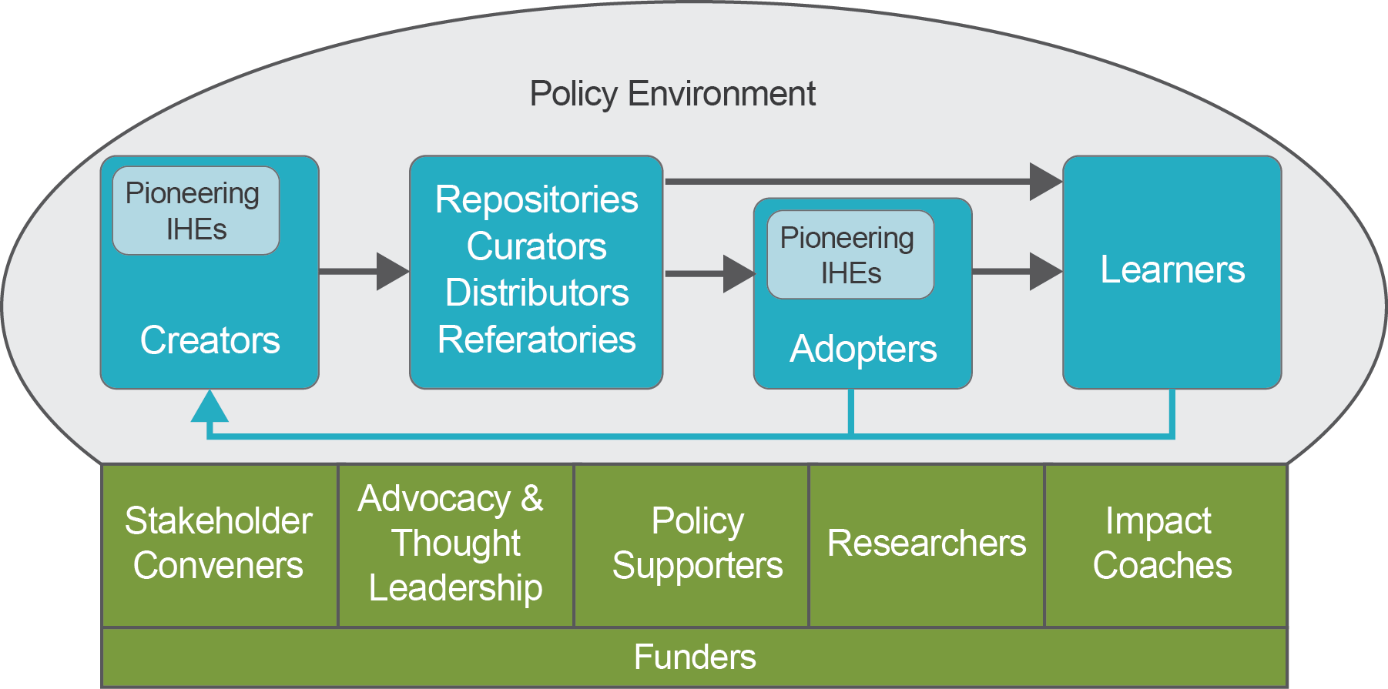
In the cycle of OER creation and use, creators of OER include institutes of higher education (IHEs) that are pioneers of OER creation (such as Delft or Carnegie Mellon’s Open Learning Initiative), as well as IHEs following their lead and individual professors and scholars who create materials. Repositories store and manage the tagging of OER with metadata so that it can be easily searched, while curators are generally concerned with ensuring content relevance and/or quality of the material. OER distributors and “referatories” do not necessarily store or curate OER, but are involved in getting relevant OER into users’ hands, since it can be an overwhelming task for faculty and curriculum developers to search individual repositories for OER they can use. They can serve as an access point to repositories (e.g., OEC’s current course search feature, which points to MERLOT II), or be more active in delivering OER to users (e.g., through instructional initiatives or Open MOOCs). There is overlap between repositories, curators and distributors, as it is not uncommon for a single provider to take on more than one of these roles. For example, MERLOT acts as both a repository and curator, while the role of OER Commons includes all three.
Adopters of OER similarly include leading institutions that have more advanced policies and practices related to widespread OER use (such as Tidewater Community College, the originators of a “zero textbook cost degree” initiative), as well as a broader set of institutions, curriculum coordinators, and individual faculty that are making choices to include OER in their educational programming. The “open” characteristic of OER also encourages adopting institutions and faculty to adapt, improve and re-share the resources, looping back to their role as creators as shown by the blue arrow. Learners are the ultimate users and beneficiaries of open resources, and through their own adaptation of learning resources may become creators as well.
Somewhat external to this flow of OER production and use are actors who play essential supportive roles. While some may not directly “touch” the OER supply chain, these actors energize the ecosystem in hopes of contributing to its capacity and long-term sustainability. Advocacy and thought leaders define and promote OER, help set agendas for OER stakeholders, and often serve as the voice and identity of the OER movement. Stakeholder conveners provide concrete opportunities for members of the OER ecosystem to collaborate and strengthen one another. Policy supporters try to improve the OER policy environment through advocacy, IP support and/or policy consulting, while researchers increase the quantity and quality of OER research. Impact coaches are organizations and/or individuals who provide hands-on support to IHEs and/or networks of IHEs to implement OER in a substantive and sustainable way. Finally, funders of OER actors and initiatives, typically foundations and governmental organizations, provide the financial support needed to support many of the essential roles above.
Perhaps not surprisingly for a relatively small social ecosystem still striving towards sustainability, institutions and organizations we reviewed tended to wear multiple hats. For example, the Hewlett Foundation is a major funder and stakeholder convener, while also playing a key role in thought leadership. OEC is well known for its roles in advocacy/thought leadership and in global convening. OER Africa is at the same time an important convener, advocate and policy consultant in sub-Saharan Africa. Pioneering IHEs, in addition to being users, creators, repositories and/or curators, also tend to serve as thought leaders and often as researchers. We also noted that impact coaches are relatively few in number and occupy an emerging niche, which will bear on one of our recommendations for future roles for OEC.

Accomplishments and Challenges of the OER Ecosystem
By all accounts, OER availability and its penetration into the global system of higher education has come a long way since the inception of the movement in the early 2000’s. While a comprehensive overview of the status of the system is beyond the scope of this study, informants from around the world commented on a marked increase in awareness and use of OER by faculty and students. An interviewee from East Asia remarked on an “obvious” and “very important” trend that more higher education faculty in the region seem willing to try new ways of teaching using online materials. In Africa, several universities now have webpages dedicated to OER, in contrast to a few years ago when no one on those campuses had heard of OER. In South America, there appears to be more awareness among some educators about how licensing works, and policy changes in that region have included passing of federal and state OER bills. A North American interviewee said it is now hard to imagine that any faculty involved in online or blended learning has not heard of OER, and that more and more students are also seeking it out on their own although they may not know the term “OER.”
According to global experts in OER, open content is also becoming accepted in places where it had not been previously. There is space for consideration of OER in procurement processes, for example, which was not the case before. Globally, traditional publishing business models have been under threat, causing publishers to acknowledge the relevance of open, alternative licensing schemes. Many of these actors are now incorporating OER content in what they offer, validating efforts of the OER movement. Particularly in North America, open textbooks have become much better known, and interviewees claimed that these, among other resources, have resulted in millions of dollars in savings for students, and access to learning that they otherwise might not have had.
Associated with this, in the experience of some interviewees, faculty are becoming more thoughtful about how learning is happening in their courses. “[Faculty] who in the past, didn’t think about what textbook is used, using the same one over and over again… that is shifting. That is a massive shift.”
Yet adoption, much less pedagogical change, has been relatively slow to scale. In a 2014 Babson survey of the use of open educational resources by US higher education faculty, between two-thirds and three-quarters of faculty say that they are unaware of OER (Allen and Seaman, 2014), although some may use OER without knowing what it is called. Similarly, a 2016 US-based survey by the Independent College Bookstore Association (ICBA) found that 75% of faculty either are not aware of OER or have never reviewed or used OER, and just 15% use OER actively in their courses (Green, 2016). Furthermore, both awareness and use of OER in the developing world still lags far behind the state of uptake in more advanced economies such as America.
What stands in the way of more rapid adoption? Based on what we heard in global interviews as well as on broader observations, notable challenges include the following:
- Lack of awareness of OER continues among faculty and administrators. There is also confusion about the difference between “open” and “free”, as many faculty believe that using resources on the web (e.g., YouTube video clips) constitutes adoption of OER, and in many parts of the world issues of copyright are not a driving concern.
- Faculty incentives typically do not support development or use of OER. On the production side, some faculty fear a loss of personal revenue if they openly license their intellectual property, and in some systems faculty-designed course materials may belong to the institution so instructors do not have the freedom to release it openly. Incentives for use can be misaligned as well, with course redesign to leverage OER requiring a significant investment in faculty time, while students are the ones who reap the cost benefits. Systems of tenure are often in conflict with both production and consumption: open publications tend not to be sanctioned as scholarly pursuits, and requirements to focus on research can be at odds with the time it takes to integrate OER into instruction.
- Resource quality is an open question. On the 2014 Babson survey, while faculty ranked the OER hallmark of low cost near the bottom of their list of priorities in the selection of materials (cited by 2.7%) and ease of adaptation fared only slightly better, top criteria included proven efficacy (59.6%) and trusted quality (50.1%) (Allen and Seaman, 2014). At this early stage in their development, the efficacy and quality of open educational resources are largely untested.
- The field of OER research has yet to come to maturity. Much current research is conducted by advocates; widespread objective, empirical research is lacking that would be able to provide fodder for advocacy and practical guidance for decision-making.
- The tradition of “academic freedom”, particularly in the U.S., makes adoption of any new types of content in postsecondary a slow process. In most institutions, faculty members must be converted one by one; institutions with more centralized decision-making that can enact policies to adopt OER at scale are rare.
- The OER ecosystem lacks a proven supply model. Publishers have spent decades building comprehensive catalogues of instructional materials across disciplines and at all levels, setting a high bar for coverage that OER has not yet been able to meet. Because uptake of OER does not typically generate revenue for developers, many major players are still supported primarily by philanthropy. “Open” business models are still an emergent field, and public funding for creation of OER content has not emerged as a solution globally (though in the U.S., some state-supported initiatives such as textbook collaboratives show promise).
- Lack of supply in local languages hinders local adoption. Most of the major OER repositories are in English, requiring significant investment to translate into a wide assortment of world languages. While some initiatives are experimenting with crowdsourcing of translation, this is not yet a widespread solution.
- Free and online (but not open) resources continue to proliferate, adding to the confusion. The vast majority of MOOCs and educational apps are prime examples.
Against this backdrop of opportunities and challenges, we turn back to OEC, and offer considerations for future directions that build on the organization’s substantial strengths to date and lay the groundwork for continued evolution to meet the needs of the field.

Charting a Future Role for OEC
Both survey responses and interview data indicated that OEC is highly respected and appreciated for its role in convening an international community interested in open educational resources and open education more broadly. OEC’s executive director has an extremely strong network and deep understanding of the promise and challenges connected with open education in countries around the world. But at the same time, it is clear that an organization so heavily dependent on the expertise and efforts of a single individual is a vulnerable one. Restricted revenues prevent OEC from hiring more staff, and the lack of staff precludes developing and implementing new products and services that might produce revenue.
In a way, what we have is a particularly acute case of the innovator’s dilemma. To survive, OEC needs to develop new lines of activity that can generate revenue, but it cannot afford to turn the attention of its very small staff away from the bread-and-butter convening and field representation activities that have established its reputation.
At the same time, OER itself is facing a number of challenges. Without an organized, proven supply model, available OER resources can seem haphazard. There are a great many of them, but finding the right kind of material for a specific subject and a specific learner population in that population’s language can be difficult. And even if the supply and access problems were solved, OER faces issues on the demand side that stem from the different incentives and perspectives of higher education administrators and faculty. Administrators seek ways to cut costs, either for their institution or for their students, and many are open to the idea of making OER part of that effort. But the work of implementing OER, finding the right resources and then making changes to courses and pedagogy to take advantage of them, generally falls on individual faculty members. No one likes a change imposed from above, yet if it is left up to individual faculty members entirely, there will be few adoptions of OER at a broad enough scale to really make education more open and affordable for everyone.

Steps for Incremental Improvements
Our conversations with OEC’s director, board members, and partners suggested that there are several steps OEC can take to refine its current set of activities and its ability to deliver on its mission as a convener and thought leader in open education.
- Decline consulting assignments that take up the director’s time. In recent years, OEC has taken on some consulting agreements in an attempt to bolster revenue. As consulting assignments often do, some have changed direction and grown in scope to the extent of being a distraction from the core mission and a significant drain on the OEC director’s time. Without a larger staff to execute consulting assignments and a tight linkage between assignments and the OEC mission, these activities appear to be a net negative.
- Review the nature of the data requests to the OE Information Center to identify any patterns indicative of areas where OEC could add value. SRI’s review of Information Center posts suggests that users are looking for authoritative resources they can use in their work promoting OER and open education. They would like to have access to topic-specific research summaries, presentation materials, and basic information on open education they can use in their advocacy work.
- Add OEC Board members who can assist with membership drives and fundraising. Current OEC Board members bring a global perspective and sincere appreciation of OEC’s mission but they were not selected for their role as decision makers at higher levels of education systems nor for their ability to contribute funds and raise money from others. OEC should start making plans for an expanded board, adding such influentials and then replacing anyone who retires or rotates off with a person with this profile. Alternatively, OEC may want to consider establishing a separate and complementary group whose function is financial development, with membership drawn from senior players in the open software industry and other sectors that may offer new sets of connections and skills.
- Continue to attend to clarity of messaging post-OCWC. As we described earlier, some confusion still persists about the meaning of “open education” in OEC’s mission, action areas of focus related to it, and the organization’s relationship to its historical OCWC identity. Honing these messages is an active focus of OEC that should continue. Related activities could include adding an inspirational and communicative tagline to the organization’s name, and continuing to craft increasingly well-specified statements, perhaps with the goal of offering the OEC website as a go-to source for an accepted definition of open education.
While we judge these steps to be worth undertaking, and together they have some potential to generate additional revenue and to free up some of the director’s time to focus on strategy planning and execution, we do not expect any of them to generate enough revenue to enable OEC to build staff capacity and financial health to a degree that will ensure sustainability. It is for this reason that we suggest framing a new strategy to be implemented concurrently with maintenance of OEC’s current networking and knowledge sharing activities.

Option for a New Strategy
Any new strategy OEC adopts should be consistent with its core mission and should provide demonstrable value that potential funders (whether philanthropists, tertiary education systems, or governments) would be willing to support. Our review of the current OER ecosystem and of the needs expressed by OEC members, especially those from developing countries, suggests that institutional OER adoption efforts are often missing some key elements in the adoption chain shown in Figure 11. While individual faculty adoptions are evident, few institutions have created a coherent strategy for leveraging OER in a way that enhances course quality and reduces costs for entire academic programs. Such efforts require skills in strategic planning, organizational change, evaluation, and information technology infrastructure as well as detailed knowledge of existing OER resources. Most higher education institutions either lack some of these capacities or have yet to assemble them around the challenge of OER implementation. These needs are particularly acute in developing countries, where arguably OER could make the biggest difference in people’s lives.
OEC’s director is extremely knowledgeable about what is needed to implement OER at scale and has an unsurpassed network of contacts within the OER ecosystem around the world. We believe that OEC could develop a “theory of action” for the process and critical components of institutional OER adoption, and could ultimately lead the provision of a set of coordinated services to governments and institutions that need help in securing the components and executing the steps in the theory of action. At present, OEC does not have the staff to carry out these activities, nor would it make sense to try to do so without local consultants based in the relevant country.
What we envision is codification of a set of processes and tools to support OER implementation within entire universities or degree programs. Governments or university systems could come to OEC, which would act as a process manager and as a broker, identifying resources that fit the clients’ needs as well as assembling a support team including in-country consultants to assist in initiative planning, faculty training, evaluation, and so on. OEC would not perform all of these services itself, but it would provide a branded “method” supported by individuals trained in the OEC approach who also have knowledge of the local education system, language, and context.
For participating higher education institutions, there would be two important values: first, broad adoption of OER can bring world-class learning resources to their learners and provide the opportunity for reflecting on and improving the quality of their academic programs. Second, working with OEC and the consultants it engages in co-designing the institution’s strategy and implementation plan will build staff capacity for carrying out their work supporting the quality of OER-based academic offerings. These benefits would be particularly important for institutions in developing countries, as suggested by representatives from them who participated in our survey and interviews.

The Case for Investing in OEC’s Strategy Shift
Laying out and codifying the OEC “method” for implementing OER effectively at scale will take some time, and we believe it is important also for OEC to have a demonstration of its ability to engage successfully in this kind of work. In addition, there will surely be some learning that has to occur on OEC’s part the first time it undergoes a project to take a client all the way from interest in OER to actually implementing it effectively on a broad scale. The needed capacity building and organizational development are unlikely to occur without some philanthropic investment in OEC as an organization and in the initial “beta testing” of the approach. It would be very helpful to underwrite part or all of the costs for an initial partnership with a higher education system that can then serve as a proof of concept and a model in its region of the world.

Final Reflections
This is an exciting time for the Open Education Consortium. In its 6-year history the organization has built a strong reputation as a thought leader and convener of the global open education community, and its broad range of connections with key players in the open education ecosystem offers a strong foundation for impact. At the same time, sustainability is fragile and new opportunities must be defined in order to sustain growth. We believe that OEC is uniquely positioned to capitalize on its global network and expertise to launch new initiatives that can contribute to not only to the spread of OER, but also to helping ensure that those resources serve the ultimate objective of open education.

References
Allen, I. E., & Seaman, J. (2014). Opening the curriculum: Open educational resources in US higher education, 2014. Babson Survey Research Group.
Boston Consulting Group. (2013). The open education resources ecosystem: An evaluation of the OER movement’s current state and its progress toward mainstream adoption. Retrieved from http://www.hewlett.org/sites/default/files/The%20Open%20Educational%20Resources%20Ecosystem_1.pdf
Green, K. C. (2016). Going digital: Faculty perspectives on digital and OER course materials. ICBA. Retrieved from http://www.campuscomputing.net/sites/www.campuscomputing.net/files/GOING%20DIGITAL%20-%202016%20ICBA%20Faculty%20Survey_2.pdf
OEC (2015a). About the Open Education Consortium. The Open Education Consortium Website. Retrieved December 5, 2015, from http://www.oeconsortium.org/about-oec/
OEC (2015b). How to join. The Open Education Consortium Website. Retrieved December 9, 2015, from http://www.oeconsortium.org/about-oec/membership/how-to-join/
Smith, M. S. (2013). Ruminations on research on open educational resources. Retrieved from http://www.hewlett.org/library/consultant-publication/ruminations-research-open-educational-resources
World Economic Outlook Database October 2015 – WEO Groups and Aggregates Information. (2015). International Monetary Fund Website. Retrieved November 30, 2015, from https://www.imf.org/external/pubs/ft/weo/2015/02/weodata/groups.htm
The William and Flora Hewlett Foundation, (2013). White paper: Open educational resources. Breaking the lockbox on education. Retrieved from http://www.hewlett.org/sites/default/files/OER%20White%20Paper%20Nov%2022%202013%20Final.pdf

Appendix A. Evolution of the Open Education Consortium
Table A1. Main OEC activities since 2008 (source: materials from OEC and Hewlett Foundation).
Time | Key activities
2008 | OpenCourseWare Consortium (OCWC) is formalized. Primary goal was expansion of production of open course materials.  Transition to become a 501(c)3.
2009 | OCWC becomes independent of MIT’s OCW project. Focus efforts on supporting development of OCW, and OER projects.
2010 | Staff hired and trained.  Membership dues introduced.  Double frequency of Board meetings to 4/year.  OCWC Global Conference in Hanoi, Vietnam (May).  Work with Remilon Inc. to identify user needs via pop-up survey.
2011 | Develop and implement financial policy.  BoD approves shift of mission from OCW production to realizing the potential of OER/OCW to improve teaching and learning around the world.  OCWC Global Conference in Cambridge, MA, USA (May).  Merger with CCCOER (summer). Community college outreach manager hired (fall)  Open Education Week conceived (October).
2012 | Pilot course catalog; Translation of website into Spanish, French and Korean.  OER Hub interviews faculty and students at 12 community colleges; Showcase on website (March, April).  Open Education Week 2012, Inaugural (March).  OCWC Global Conference in Cambridge, UK. Partner with SCORE of UK Open University. 300 attendees from 43 countries (April).  Over 20 presentations by staff and board members.  Begin conducting webinars  Begin monthly newsletter, including quarterly in-depth newsletter.  Faster processing of membership applications.  OCW toolkit in continual development and expansion. Translations to French and Spanish.  Include Open Textbook list and RDF metadata recommendations on website.
2013 | Continue webinars, including series focused on Community College.  Continue presentations, newsletters, Open Education Week 2013 (March).  Host OCWC Global Conference in Bali, Indonesia. BoD meeting includes extensive discussion on future directions (April).  President of CCCOER elected to OCWC board (April)  Complete project on clarifying legal issues regarding copyright in cloud hosting of OER (May)  Convene/consult on how OER could support existing programs on STEM education for women (until Spring 2014).  Conduct OER Impact survey (Fall).  Begin consultancy with Root Cause (November).
2014 | Continue webinars, newsletters, Open Education Week 2014 (March).  Host OCWC Global Conference in Ljubljana, Slovenia (April). BoD develop values statement.  Agreement with edX on Open MOOC pilot project (March)  Change mission and name to the Open Education Consortium (May)  Activate membership to provide information on Open Education to White House Office of Science and Technology Policy for meeting about Open Global Partnership (US-African Union dialogue) in July 2014.  Begin quarterly online membership meetings (June).  Facilitate pilot of 2 open MOOCs (Fall).  Work with the Organization of American States and Virtual Educa to expand offerings of the Campus Virtual de las Americas to include OER, open courses and MOOCs.
2015 | Continue monthly webinars, newsletter, and conference presentations.  Open Education Week is now well established.  Host OE Global Conference in Banff, Alberta (April).  Decide to develop Open Education Information Center (shift from toolkit).  Integration of search function with MERLOT.  Professional development consultancy for female educators from Saudi Arabia  Facilitate 6 open MOOC pilots in partnership with edX.  Curative consultancy with Smithsonian.  Consultancy with UniMinuto in Columbia, on quality assessment and digital strategy (July).  Launch Open Education Information Center (fall).

SRI Education, a division of SRI International, is tackling the most complex issues in education to identify trends, understand outcomes, and guide policy and practice. We work with federal and state agencies, school districts, foundations, nonprofit organizations, and businesses to provide research-based solutions to challenges posed by rapid social, technological and economic change. SRI International is a nonprofit research institute whose innovations have created new industries, extraordinary marketplace value, and lasting benefits to society.
Silicon Valley  (SRI International headquarters)  333 Ravenswood Avenue  Menlo Park, CA 94025  +1.650.859.2000  education@sri.com | Washington, D.C.  1100 Wilson Boulevard, Suite 2800  Arlington, VA 22209  +1.703.524.2053  http://www.sri.com/education

The classification is based on the most recent International Monetary Fund criteria (World Economic Outlook Database October 2015), which OEC uses to determine their membership fees.
If the labels on the figure to the right are difficult to read: this reports the data on 4-year/2-year institutions (etc.) as described in the paragraph above. This will corrected in the final draft.
From here on, “OEC institutions” will generally refer to all OEC members, including organizations and corporations that are not institutes of higher education.
The slight variation of the sample size in this, and other figures in this report, indicate that some respondents skipped a few sub-questions comprising the figure.

